Summary of the progress on lung segmentation

Focus of our team last semester was on Lung Segmentation. Particularly we were trying to improve on already existing neural network architectures for lung Segmentation as well as creating a neural network from scratch. I used Google Colab and Microsoft Azure to train the models.

I have implemented a U-net from scratch relying on this paper (https://arxiv.org/abs/1505.04597). I have attempted to write the code myself for data loading and dataset augmentation.

I have also downloaded a Github repo (https://github.com/IlliaOvcharenko/lung-segmentation). It used U-net architecture with VGG11 encoder. I have tried several things to improve the efficiency of the model. Particularly, I have changed the encoder from VGG11 to Resnet18. I have increased the learning rate to 0.0005 as well. The results are summarized below and are less accurate than results achieved in the original model (base results: Jaccard score - 0.9268, Dice score - 0.9611).

Further experimentation to be tried:

- k-fold cross validation

- transposed convolution instead of up-scaling

- SegNet encoder-decoder architecture

Experiments

1. Resnet Encoder. With init layer (that takes in 3 channels and output 64). Learning rate = 0.0005

Results: Dice - 0.9598, Jaccard – 0.9244, avg. test loss = 0.06439

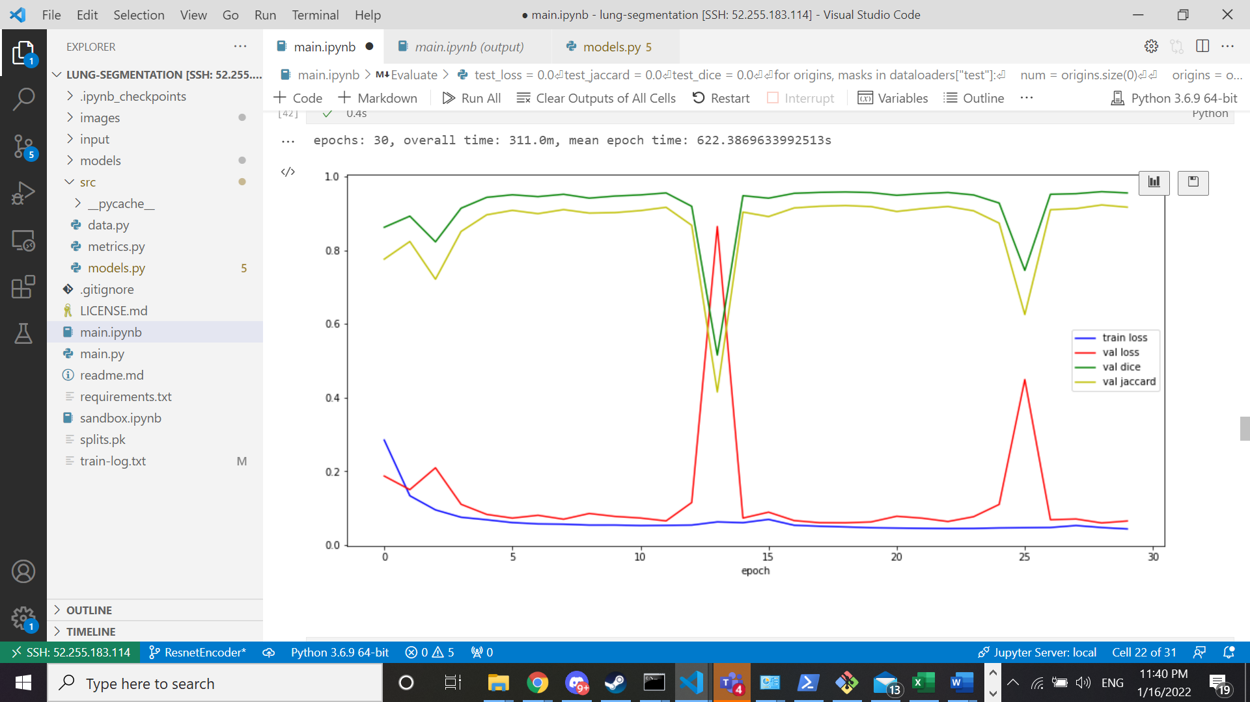

1. Resnet Encoder. With init layer. 30 epochs. Learning rate 0.0005

Results: Dice - 0.9597 , Jaccard -0.9245 , avg. test loss - 0.05885

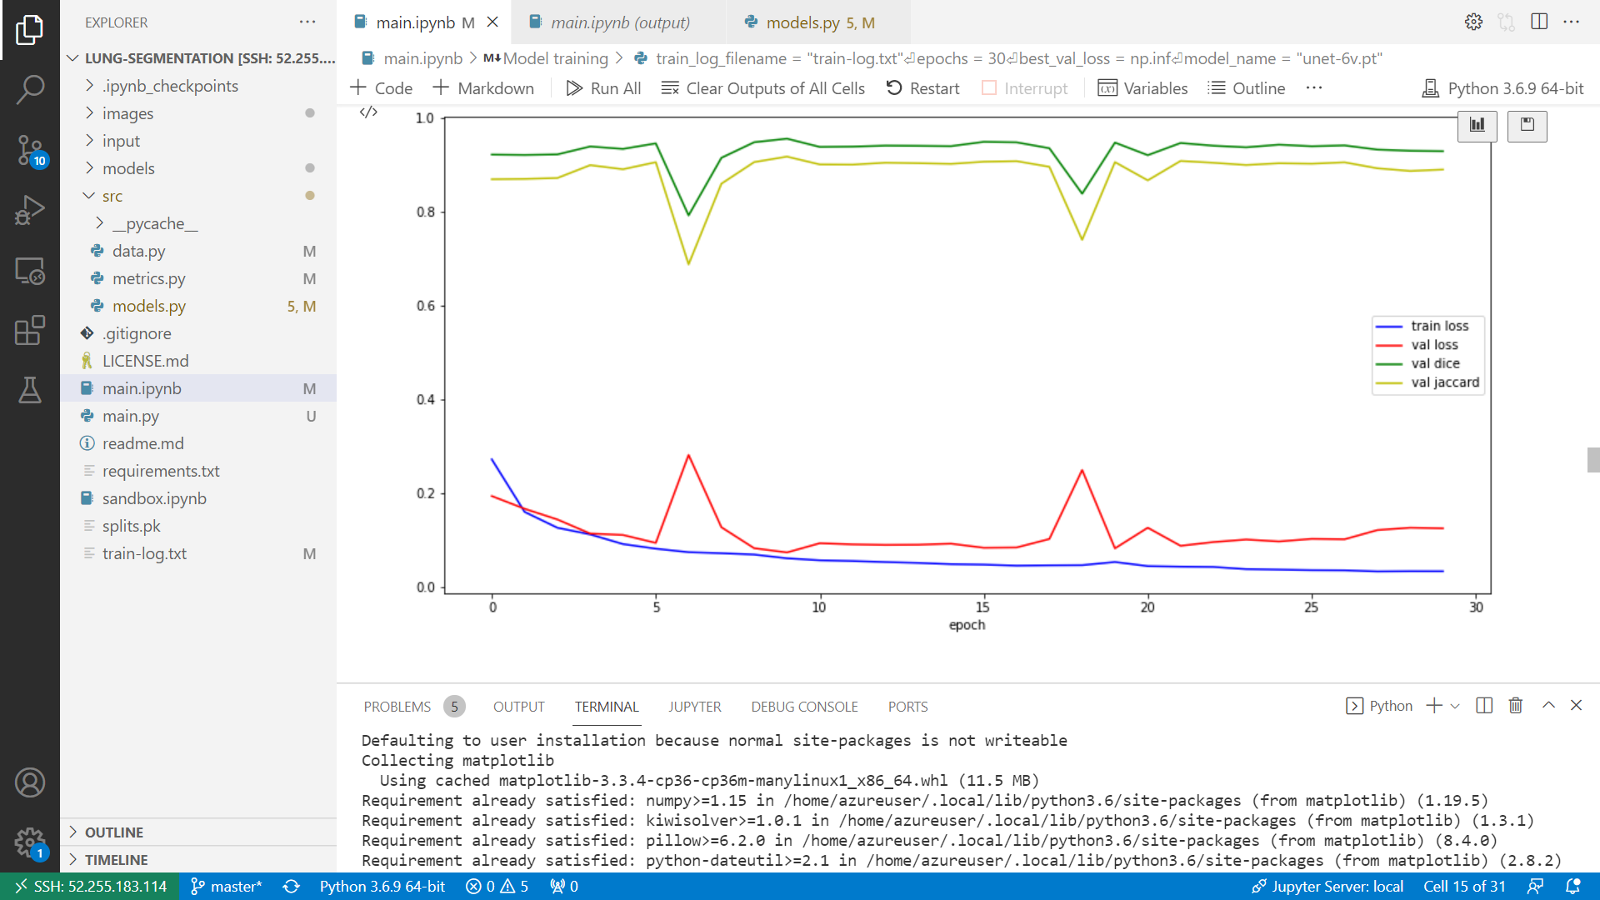

Links to github-repo:

1. Resnet Encoder : <https://github.com/trupewate/lung_segmentation>
2. Lung segmentation from scratch: https://github.com/trupewate/Lung-Segmentation